General Scientific Information

CIESM SUB 2

Rationale
The CIESM-SUB1 cruise, was successfully completed in July. The SUB 2 is a follow up multi-disciplinary cruise, which brings together researchers from across the Mediterranean Sea.

Scientific Objectives
Geologists, oceanographers, hydrologists, biologists, will work together on the exploration of a poorly known area, looking for new features as well processes which are not well understood in the Tyrrhenian Sea. Hydrobiology surveys will focus on seasonal patterns in physical variables and biological components in the central Tyrrhenian Sea. Geoscientific surveys will investigates a different area, the Sardinia-Sicily Channel, an active geological and tectonic area.
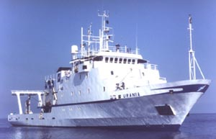

The R/V Urania is a research vessel of 61 m that can take 36 scientists on board. It is equipped with laboratories for analyses and geoscientific technology.

SUB 2 Leg 1

Dec. 6-13 Sardinia-Sicily Channel

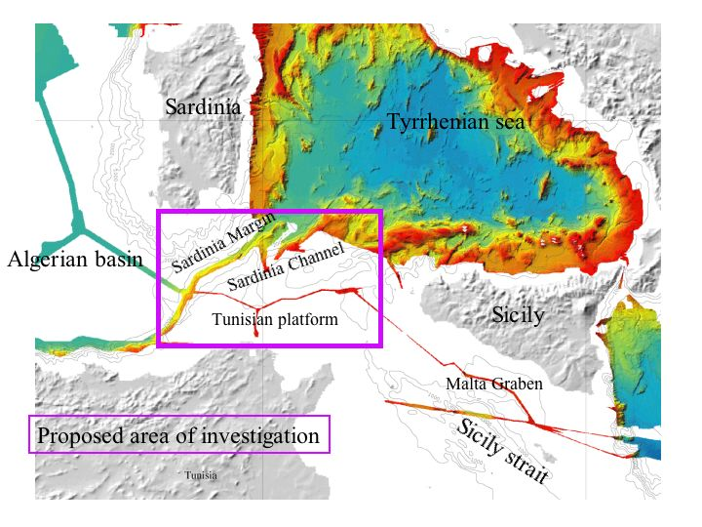

This map of the relief of the sea floor of the Tyrrhenian Sea, is showing in colors the already mapped parts as well as the investigation area of the Sardinia-Sicily Channel (violet)

Mapping and Sampling

The R/V Urania will navigate between the northwestern tip of Sicily and southern Sardinia; where a geological survey of the seabed will be conducted. Hydrologists will carry out studies on the deep-sea water masses as well as biologists will take samples at several stations on its way. The chief scientist, Francesca Boudillon, who is responsible for the coordination of the research activities on board, will coordinate the investigations. She is an expert in marine geology and morpho-bathymetry. Together with a team of geoscientists the sea floor of the Sardinia-Sicily Channel will be surveyed. Although this area is considered as a tectonic key area in the Mediterranean, it is still poorly known so far. This campaign may contribute a better understanding of active geological and tectonic features in the transition zone of the North African chains and the Alps-Apennines by seismic surveying seafloor surface. Alessandra Savini and Sebastien Garziglia will enlarge and complement already existing maps of the relief of the seafloor with new measurements. The technical equipment used for this cartography is the multi-beam echo sounder, a tool for acoustic imagery. Renato Tonielli, Sara Innagi, Paola Mussoni and Mohamed Sahabi will also be exploring sea floor formations like seamounts using applied geophysical survey techniques.

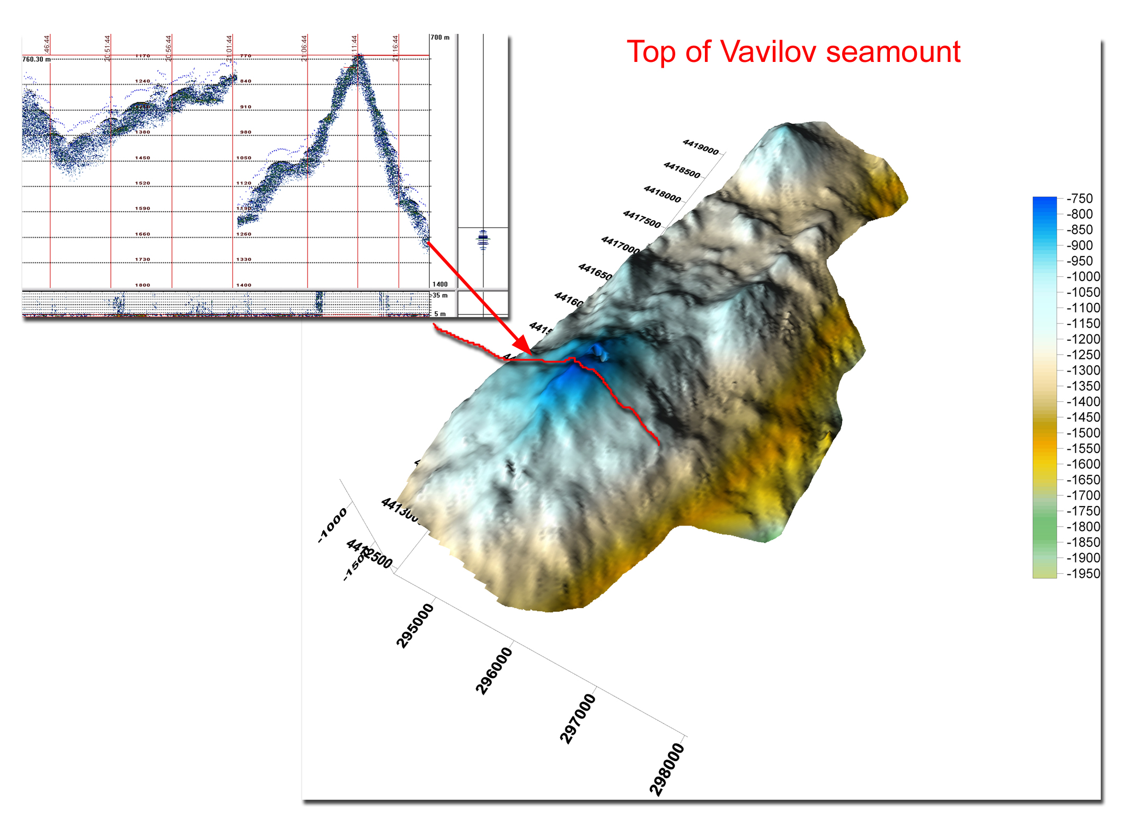

The Vavilov volcano is elongated NNE-SSW for 40 km and stands 2800m above the abyssal plain with summit depth at 730m. The processed 3D surface view provided by the multibeam data is shown within a view from the EA400 echo sounder data. The map, covering an area of about 20 km square on its southern sector, clearly show the top of the volcano where the rough topography, characterized by circular cones, is well documented for the first time at this high resolution. (From SUB-1 Cruise)

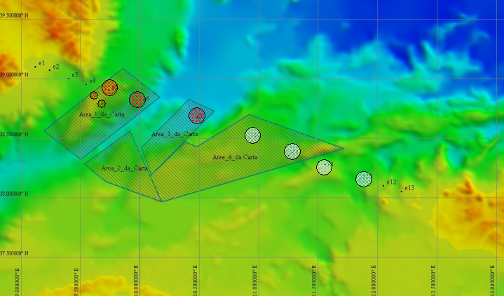

LEG-1 Sampling stations
Site Lon (°E) Lat (°N) approx. depth

E6 10,00 38,80 1400 m

E7 10,45 38,65 2400 m

E5 09,74 38,90 250 m

Ex 09,66 38,89 550 m

Ey 09,70 38,83 600 m

Sampling of the deep sea floor by trawling and coring methods will also be done using the box- and the multi-corer. They will collect and probe up to 40 centimeters of the seafloor. Scientists Gian Marco Luna and Daniella Zeppilli are particularly interested in meiofauna, the diversity of the benthic bacteria and viruses. Seamounts are hotspots of biodiversity in the deep sea so they will receive special attention during the CIESM SUB2 cruise. The water mass properties, such as temperature and salinity will be measured on numerous stations on the track of the R/V Urania across the Sardinia-Sicily Channel. The study of these hydrological measurements is important to characterize the water bodies, to understand processes and interactions and to detect changes. Oceanographic observations of physical parameters are commonly measured with a CTD (data logger used in oceanography designed to monitor conductivity, temperature and depth) through the whole water column will be gathered by Giuseppe Siena, Francesco Raffa, and Francesco Soraci.

Hydrographic sampling of the entire water column will also provide Giovanna Maimone with material to analyze the composition, abundance and biomass of phytoplankton and prokaryotic (cells that lack a membrane-bound nucleus) assemblages. One of the results she found during the SUB1 cruise, that phytoplankton communities, of which the active components are concentrated in the euphotic zone (upper ocean layer), e.g. those exposed to sufficient sunlight for photosynthesis, were dominated by small-size cells rather than diatoms (single cell organisms with a silica shell).

LEG-1Time Schedule
A time estimate of activities is based the departure on the 6th December post meridian and favourable sea-weather conditions. This time schedule takes into account that during some specific days navigation in sector 1 (thus sampling activities) are not allowed.

6 Dec | 08.00/16.00 | Dock
6 Dec | 16.00 | People on board | Departure | 28 h transfer
7 /8 Dec | 20.00/8.00 | Chirp data and multibeam acquisition | 1 sound velocity profile | Sector 1
7 /8 Dec | 8.00/20.00 | Sampling (ctd, box core, gravity core) | E5, E6, Ex, Ey | Sector 1
8/9 Dec | 20.00/12.00 | Transfer -Chirp data and multibeam acquisition | Every 12 h sound velocity profiles | Sector 3
8/9 Dec | 12.00 – 18.00 | Sampling (ctd, box core, gravity core) | E7 | Sector 3
9/10  Dec | 18.00/20.00 | Chirp subbottom and multibeam acquisition | Every 12 h sound velocity profiles | Sector 3- sector 4
10/11  Dec | 20.00/20.00 | Chirp subbottom and multibeam acquisition | Every 12 h sound velocity profiles | Sector 4
11/12  Dec | 20.00/10.00 | Chirp subbottom and multibeam acquisition | 1 sound velocity profile | Sector 4
12/13  Dec | 10.00/10.00 | Final data report, dvd data burning and backup |  | 24 h transfer
13  Dec | 10.00 | Docking at Messina harbor |  | disembark

CIESM SUB 2 Cruise Partners
Scientists from various CIESM member states are able to participate in the cruise because of the broad range of interests in selected target area. The new-old concept of “multi disciplinary” has been the main driver for selecting the sampling area that should have been strategic in merging independent, self-standing interests of each discipline. The participation of scientists from Morocco, Tunisia, and Algeria reflects CIESM interest in promoting trans-Med research activities for enhancing transfer of knowledge across the Mediterranean Sea from the North shore to the South shore.

CIESM is pleased announce our sponsors who have made the SUB 1 and SUB 2 cruises possible. The Italian Ministry for the Environment and Territory, Consorzio Interuniversitario per le Scienze del Mare (CoNISMa), and the National Research Council, (CNR), and the Bonino-Pulejo Foundation,

Institute for the Coastal Marine Environment (IAMC-ME) sect. Messina Italian National Research Council (CNR), Messina, Italy,
Activity Molecular microbial diversity and functional markers, biological pump (ETS measurements) biogeochemistry

Polytechnic University of Marche Faculty of Sciences, (SC-UNIAN), Ancona, Italy
Activity: Diversity of Benthic meio-, and macro- fauna; biochemical composition of sediment organic matter

Observatoire Oceanologique (OBS-CNRS), Villefranche/mer, France
Activity: Diversity and functioning of zooplankton communities

Milano-Bicocca University Department of Geological Sciences and Geotechnologies (DGSG-INIMIB), Italy
Activity: Navigation, bathymetric and geophysical mapping, planktonic assemblages in the bottom sediments

Lab. de Microbiologie, Geochimie et Ecologie Marines Centre d'Océanologie de Marseille,( LMGEM CNRS), France
Activity: Functioning of deep sea microbial communities (effects of physical parameters including high pressure)

Dept. Of Animal Ecology and Marine Biology, University of Messina, (DAEMB-UNIME), Italy, Activity: Distribution of cultivable bacteria

Institute of Meteorology and Oceanography (IMO-UNINA) Napoli, Italia
Activity: Physical Oceanography

Stazione Zoologica Anton Dohrn, (SZN) Napoli, Italy
Activity: Biological Oceanography

Leg I Participants
Project (RP) or expedition leaders (EL)
Laura Giuliano (RP) Comité International pour l'Exploration Scientifique de la Mer Méditérranéenne (CIESM)
Tel. +377 93 30 38 79 - Fax. +377 92 16 11 95 E-mail: lgiuliano@ciesm.org
Francesca Budillon (EL, Leg I) Istituto per l’Ambiente Marino Costiero (IAMC), sezione di Napoli
Tel: 081 5423839 - Fax: 081 5423888 E-mail: Francesca.budillon@iamc.cnr.it
Franco Decembrini (EL, Leg II) Istituto per l’Ambiente Marino Costiero (IAMC), sezione di Messina
Tel.: 0039 090 669003 - Fax.: 0030 090 669007E-mail: franco.decembrini@iamc.cnr.it
 | Name | Email | Affiliation, address | Activity
1 | Francesca Budillon | francesca.budillon@iamc.cnr.it | CNR-IAMC  via A. Vespucci, 9  Napoli, Italy | Geology
2 | Renato Tonielli | renato.tonielli@iamc.cnr.it | CNR-IAMC  via A. Vespucci, 9  Napoli, Italy | Geology
3 | Sara Innagi | sara.innangi@iamc.cnr.it | CNR-IAMC  via A. Vespucci, 9  Napoli, Italy | Geology
4 | Paola Mussoni | paola.mussoni@unipr.it | Università di Parma  Dip. Scienze della Terra  Parco Area delle Scienze157/A,  Parma, Italy | Geology
5 | Alessandra Savini | alessandra.savini@unimib.it | CoNISMa –  Univ. Milano- Bicocca  Dip. Sci. Geol. Geotec.  Piazza della Scienza, 4  Milano, Italy | Geology
6 | Sebastien Garziglia | garziglia@geoazur.obs-vlfr.fr | CNRS,  Obs. Océanol.  BP48 Villefranche sur mer, France | Geology
7 | Mohamed SAHABI | msahabi@hotmail.com  sahabimohamed@yahoo.fr | Faculté des Sciences El Jadida Lab Géosci. Mar. Env.  BP 20, 24000 El Jadida, Morocco | Geology
8 | Carolyn Scheurle | cscheurle@ciesm.org | CIESM  16, Bvd. De Suisse  MC 98000 Monaco | Geology
9 | Gian Marco Luna | g.luna@univpm.it | UNI-AN | Meiofauna, benthic bacteria biodiversity, viruses
10 | Daniela Zeppilli |  | UNI-AN | Meiofauna, benthic bacteria biodiversity, viruses
11 | Francesco RAFFA | francesco.raffa@iamc.cnr.it | CNR-IAMC  Sp.ta S. Raineri, 86  Messina, Italy | Physical Oceanography
12 | GiovannaMAIMONE | rosabruna.laferla@iamc.cnr.it | CNR-IAMC  Sp.ta S. Raineri, 86  Messina, Italy | Biological oceanography
13 | Francesco SORACI |  | CNR-IAMC  Sp.ta S. Raineri, 86  Messina, Italy | Hydrographic sampling
14 | Siri Campbell | siri@ciesm.org | CIESM  16, Bvd. De Suisse  MC 98000 Monaco | Press Report - CIESM
15 | Werner SIEFER | siefer@focus-r.de | Focus Magazin  Arabellastr. 21  München,Germany | Press-Report  Focus, DE

